[E120] MCU panel

Disconnect all the plugs from the MCU panel.

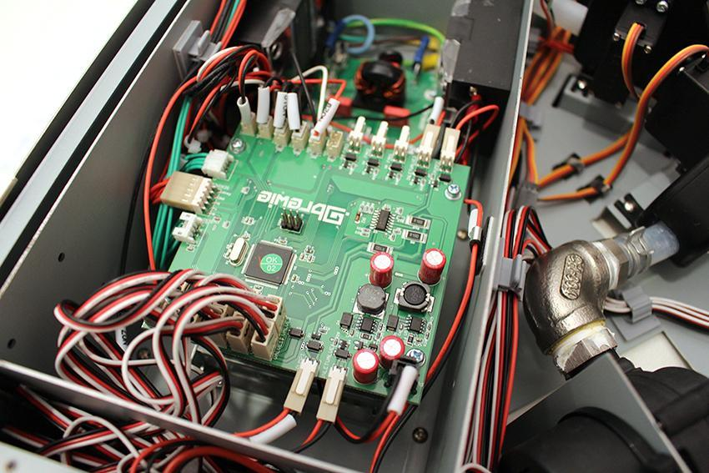

Unscrew the indicated 4 screws.

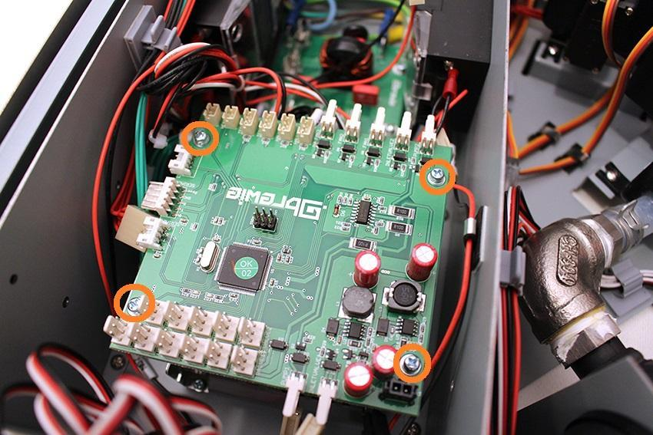

Now you can remove the MCU panel.

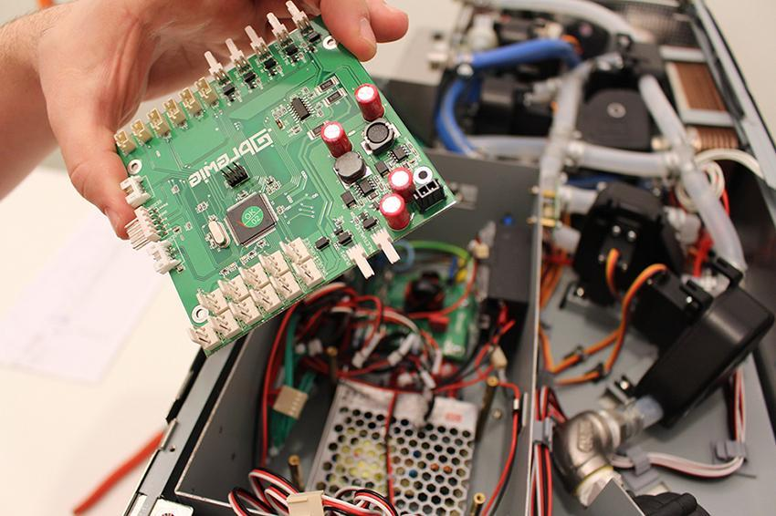

Replace the MCU panel.

Reassemble consists of the same steps in reverse.